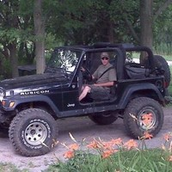 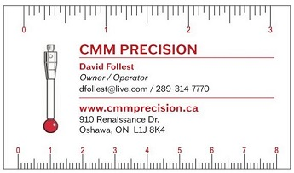

David Follest – Owner/Operator

CMM PRECISION

[WWW.CMMPRECISION.CA](http://WWW.CMMPRECISION.CA)

MECHANICAL ENGINEERING BACKGROUND

* 20+ years CMM programming expertise to various manufacturing industries
* Consult on product/process development, dialed in tooling, parts to specs
* Support highly stressed customers with tight deadlines in fast paced industries
* Review/revise CMM programming for greater efficiencies in busy QA metrology labs
* Fast on-the-spot programming to resolve dimensional discrepancies
* Advisor for CMM mechanical upkeep, calibration, repairs, preventative maintenance
* Supervise/train employees on various types of CMM equipment and software
* Fit/ form/ function expert, reverse engineering, troubleshooting, rework solutions

EXPERTISE

* Progressive experience programming wide range of CMM equipment and software
* Accumulated experience programming wide range of CMM equipment and software:
* Operated 2nd largest Coordinate Measuring Machine in Canada
* Brown Sharp One 5.5.5 CMM - running PC-DMIS
* Portable CMM Romer Arm Infinite 2.0 - running PC-DMIS
* Cube Pro Trio – 3D Printer and sense scanner
* Perceptron Vision Systems, portable measuring Faro Arm, laboratory scopes
* Measured through 3D CAD based system PC-DMIS 3.5, PC-DMIS 3.7, VIRTUAL DMIS
* CAM 2 software, GD&T, Data page, Gage V9, various other software platforms
* Operated concentration related equipment with a high degree of manipulative skills

PROFESSIONAL EXPERIENCE

2011 – CURRENT Owner/Operator of Follest CMM & Precision Tooling

• CMM programming/measurement for dimensional layouts, scanning surfaces for prototype parts, tooling, fixtures, PPAP parts, annual validations, 3rd party CMM, overflow lab work

• Consultation on design problems, dimensional discrepancies, reverse engineering, troubleshooting, rework, act as liaison between suppliers, customers, auditing registrars

2004 – 2009: CMM Supervisor Quality Control Dept. at Inmet – A Division of Multimatic Inc. Automotive (Metal stampings and welded assemblies)

• Prioritized CMM work at busy lab, supervised Perceptron vision systems including calibrations, algorithm programming, and measured parts through 3D CAD based system PC-DMIS 3.7

• Trained staff on CMM, Perceptron, Faro arm, Gauge V9, GR&Rs, co-relation studies

• Consulted with suppliers and customers to resolve GD&T dimensional discrepancies

2003 – 2004: CMM Operator/Programmer for ABB Body – Tool Making Shop (Mercedes SUV tooling and prototype parts: line set-up/ dial in)

• Operated 2nd largest CMM in Canada to dial in tooling, developed part fixturing, measured parts 3D CAD based system running PC-DMIS 3.5, provided fixture calibrations, Gauge R&R’s

• Used expert programming skills for fast paced environment, tight deadlines and highly stressed customers, communicated dimensional build issues to adjust prototype tooling

1999 – 2003: CMM Operator/Programmer for Textron Automotive Company (Automotive manufacturing for dash board full assemblies)

• Developed CMM part programs for components, finished goods, measured through 3D CAD based system PC-DMIS & VIRTUAL DMIS, consulted with QA, Production and Engineering Departments

• Ensured that QS 9000/ISO 14000 environmental charts and quality documentation were current, lab manuals, calibrations, product inspection sheets were up to date, audit information were accessible

* Ran companies GD&T courses

1995 – 1996: Robotics Operator – Croven Crystals, ultra-sonic washing and robotic X-rays

* Responsible for ultra-sonically washing crystals, operated robotic x-ray equipment
* Sorted crystals by frequency